This document should be read in conjunction with the Jewish Studies One Page Overview, the Jewish Studies One Voice Document and all curriculum documentation.
Overall School Vision Statement
At North Cheshire Jewish Primary School, we nurture our children’s pride in their Jewish identity and love of Israel.
We are an inclusive community, with happy and enthusiastic children who are valued and encouraged by our caring and conscientious staff to thrive in a safe and secure environment.
We listen to and value our children, and endeavour to instil confidence, creativity and a lifelong love of learning, in order to enable each child to reach their full potential.
Our RESPECT values underpin our rich curriculum. Within this caring culture, with its joint focus on well-being, personal growth and education, our children develop enquiring minds and essential life skills, preparing them for their journey beyond North Cheshire.
At North Cheshire Jewish Primary we aim to:
- Create a collaborative “can do” inclusive learning environment and culture in which every member of the learning community is valued and respected, including equality of opportunity for all
- Encourage all members of the school community to have high expectations of themselves, academically, morally, emotionally and socially
- Be an educational centre that works with every member of the community and recognises and praises their achievements
- To provide an enriched curriculum enabling pupils to gain a wide range of skills and knowledge to achieve high standards
Intent of our Jewish Studies Curriculum
At NCJPS, our Jewishness underpins the very reason for our existence and permeates all aspects of school life. Jewish Studies lessons aim to develop intellectual, emotional and spiritual growth, and instil a pride and self-confidence in our children of their Jewishness, and of the Jewish Homeland – Israel. We demonstrate that living committed Jewish lives firmly complements British Values. We are proud British citizens, and believe that our Jewishness can, and should, enhance our appreciation for, and understanding of, our British Values and Citizenship.
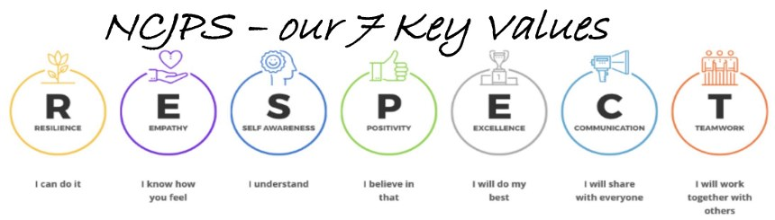
Our curriculum is underpinned by our RESPECT values and aims to inspire our children to know more and remember more.
These values are exemplified in Jewish Studies:
Resilience: Opportunities to grapple with complex life questions such as religious beliefs and our purpose in the world.
Empathy: Tzedakah, charity, and helping others, is a core Jewish value and is brought out across many Parashah and Festival lessons.
Self-awareness: Children learn to express their beliefs and opinions, and reflect on their place in the world.
Positivity: The core Jewish value of God only does good, He loves us and has a mission for all of us are reinforced constantly.
Excellence: Opportunities to emulate great Biblical leaders and great Jewish heroes throughout history.
Communication: Children articulate and share their responses to thought provoking questions on a variety of different Jewish topics.
Teamwork: Many projects are completed in groups, allowing opportunities for effective teamwork and communication.
At North Cheshire, we inculcate a deep sense of being part of the “NORTH CHESHIRE FAMILY”. This special family behaves in “THE NORTH CHESHIRE WAY. NCJPS - A SCHOOL BUILT ON KINDNESS”. These values are built upon the basic Jewish value of “Chessed - Kindness”, and is embedded across the school.
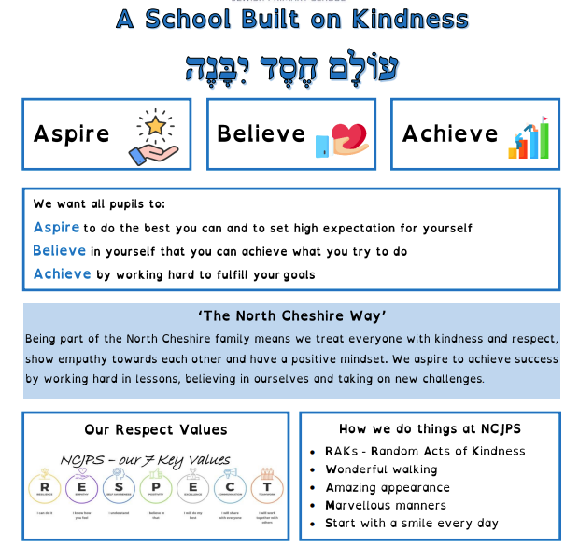

Our Jewish Studies Curriculum has the following broad aims.
Parasha
Our parashah lessons broadly follow the JCP Parashah Curriculum, with elements of the “Torah, Wellbeing and Me” curriculum incorporated when it supports the broader school RESPECT values. Our curriculum aims to provide a progressive teaching and learning structure where the weekly parashah is explored as a source of the mitzvot and middot according to which we live our lives as Jews. The curriculum explores social and moral issues and dilemmas relevant to children’s lives in the light of the actions of the Torah role models they encounter.
We learn the weekly parashah with increasing detail in innovative ways including drama and singing. Our parashah curriculum ensures progression across the school, with a focus for each year group, which builds on their prior knowledge from previous learning. Higher order questioning is an important tool in parashah classes that develops the children's thinking, and often stimulates brilliant questions and discussions. The content from the parashah is always made relevant to the children's daily life, either through a middah or an inspirational example from a character within the weekly portion.
The parashah display in Carmel is updated weekly to create an engaging Parasha board for childen to access.
The lessons from the parashah are further enhanced by regular “Divrei Torah” from the children in assembly, and guest speakers in Shabbat assemblies.
Tefilla and Benching
All classes have a “daily collective worship” in the form of Tefillia. Our davening and benching starts with Reception with and is steadily increased throughout the school.
Jewish Studies lessons aim to teach and understanding of certain prayers, for example, the 7 Mitzvot of Shema that is taught a part of a Year 6 project.
Shabbat assemblies are the highlight of the week. They celebrate the achievements of children but also give them a flavour of a genuine Shabbat experience. Shabbat Tefillot are progressively taught from KS1 to KS2.
In KS2, additional Shabbat Tefillot are taught in Year 4, as part of the Year 4 Welcome Shabbat project, and in Year 6, as part of the Year 6 Shabbaton.
We take great pride that our children learn benching from a very young age, and sing it with such enthusiasm and joy.
Blessings
Traditional blessings are taught in many different areas of school life, most notably when washing hands for bread or when eating a healthy fruit snack. Every opportunity is used to reinforce blessings.
A Brachot Bee project also enhances the connection to, and understanding of blessings, and this is also taught formally as part of the curriculum.

Chagim – Festivals
Our learning for the Chagim broadly follows the “Discovery Festival Curriculum”. The curriculum aims to ensure that knowledge of the Chagim is well-sequence, with clearly defined values taught across all Year groups for all festivals. The curriculum is designed to creative, engaging and relevant.
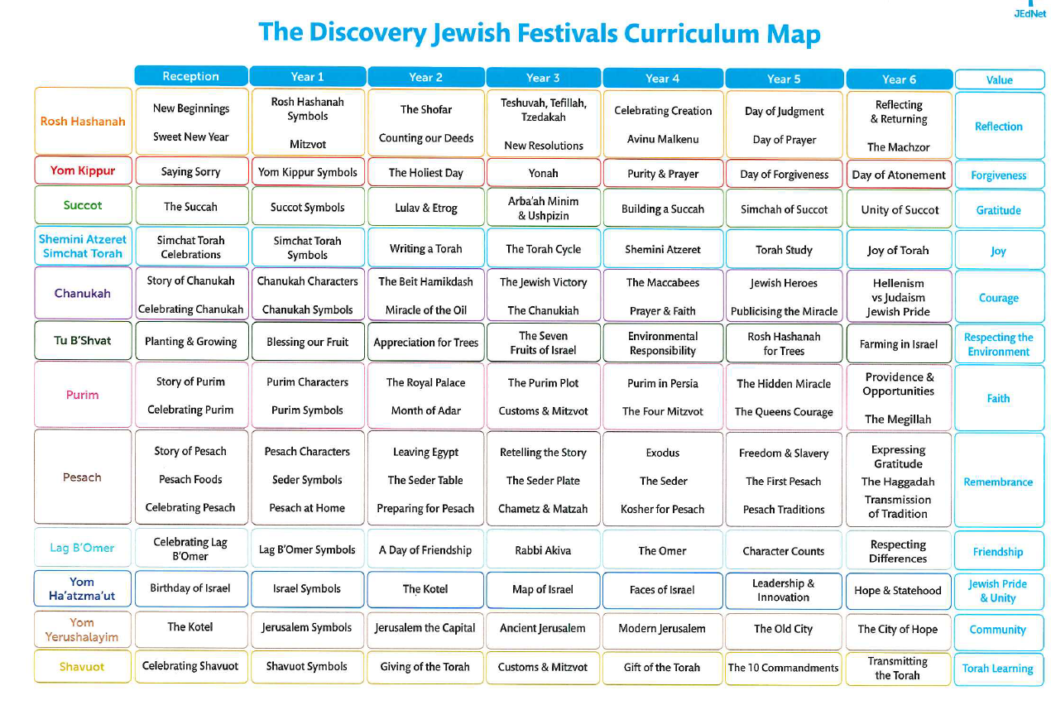

Kriah – Hebrew Reading
All children should leave NCJPS as fluent Hebrew readers.
IN FS and KS1, we use the innovative “Al Pi Darko” reading curriculum, a multisensory approach that progressively builds an understanding of Hebrew Reading. This is supported by the Aleph Champ reading programme.
When children progress to KS2, the Aleph Champ programme forms the basis of the curriculum.
We have designed an online learning platform that we use for children to do regular home reading practise, as we recognise that achieving fluency in Hebrew reading is a partnership between school and home.
Israel
The importance of Israel as a land of our heritage and belief in Zionism is key to our school ethos. We mark the special days of Yom HaZikaron and Yom Ha’Atzmaut with ceremonies and lessons to explain their significance. On Yom HaZikaron, we hold a solemn and sensitive assembly to remember the fallen soldiers. This is typically attended by parents, governors, and local rabbis.
We have a special ceremony to welcome and honour our heroes, the injured Israeli veteran soldiers.
Yom Ha’Atzmaut is celebrated in true NCJPS style. Children dress in blue and white, with additional entertainment including music, dancing, singing and exciting educational activities, together with a delicious Israeli lunch.
We are pleased to work with external organisations, who bring their own expertise to add to the curriculum. For example, we work with JAFI and UJIA, who provide a “Shinishinit” to enhance our Israel education.
Spirituality
The totality of the Jewish experience at NCJPS creates a deep connection within the children to Hashem as the Creator of the World. Hashem becomes part of the lives of our children in a real and meaningful way. Our children become proud of their Jewishness and see themselves as an integral part of the Jewish community and continuity.
We support this deep connection to Hashem, tradition and community though our curriculum, school atmosphere, and constant positive reinforcement across all aspects of the school, for example the Jewish date and weekly Parashah is on the board in every classroom.
The depth of connection is further enhanced by deeply meaningful and Jewish experiences across the year and across the school.
Please see the One Voice document and website for more information

Implementation
Children have 3 Jewish Studies and 1 Ivrit lesson per week.
At EYFS and KS1, learning is weighted towards Kriah, with up to 2 JS lessons per week in this core area, except around festivals, when 1 lesson per week is devoted to learning about the festivals and craftwork for the festivals. The third lesson is generally devoted to parashah.
In Ivrit lessons in EYFS and KS1, the children learn the sounds of different letters, supporting the JS Kriah programme.
In KS2, there is usually 1 parashah lesson, 1 lesson on festivals or Jewish general knowledge, and 1 lesson on Israel education, Hebrew reading or project work.
Learning is supported through the use of 15 dedicated ipads for Jewish Studies, with the use of the most advanced platforms for Jewish learning, including Jigzi.org, Torahlive.com and Shazak.com.
Learning is designed to be progressive, spiral and sequenced. See parashah and festival curriculum documents, and JS Long Term Plans. Key concepts and knowledges are revisited to aid long term recall. DEAL, concept reviews, games and modern applications of ancient ideas are used as methods of encouraging “Knowing more, remembering more”.
Implementation is inclusive. Children are invited to share their perspectives and beliefs, particularly where these differ to the Jewish faith. Major milestones in other religions are marked e.g. Christmas, Chinese New Year, Ramadan, Easter and teachers of other faiths are invited to share their perspectives. To encourage an inclusive mind-set, links with other faith schools are actively cultivated.
All children participate in Jewish prayers and celebrations, and this creates a deep sense of connection to the Jewish people, even for our non-Jewish students. A variety of resources are available to support children who have gaps in their background knowledge, particularly non-Jewish students who join school in the school in the upper years, e.g. parashah books, Jewish general knowledge books and various games
Communal outreach and integration is very important at NCJPS. Communal rabbis visit and teach regularly in the school, and work with the school in supporting the regular events.
NCJPS works closely with Chabad of Cheadle, SEED, JAFI, UJIA and JNF to enhance the spiritual connection to our Jewish heritage and homeland.
Jewish studies staff have access to high level CPD including the yearly conference for Jewish Studies teachers in London.

Impact
Impact is measured in several ways.
Parashah, festival, project and general knowledge learning is marked in line with the school marking policy. Feedback, questions, points for further learning and opportunities for ‘fixing’ work are offered.
Regular informal, formative assessments using techniques such as asking questions in class, reviewing work, speaking to children and the broad use of pupil voice opportunities, all provide a clear picture of how children are progressing in Jewish Studies.
We have a formal end of KS1 and end of KS2 summative assessment. These assessments are used at KS1 to provide an overall picture of children entering KS2. For both Key Stages, assessments are used as a tool to evaluate our effectiveness as a school, in achieving our stated curriculum aims. Data from these assessments informs future planning and practise.
Formal, recorded assessments take place regularly for Kriah. Children who are struggling and falling behind are given extra remedial reading sessions to close the gap and ensure they make the expected reading progress.

